George Huang bio

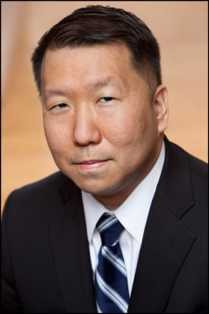

George Huang is a Director and Senior Municipal Research Analyst at Wells Fargo covering the Not-for-Profit Healthcare sector. He joined the firm in late 2011 and has more than 20 years of municipal finance experience, including more than 17 years in the not-for-profit healthcare space. George has been ranked by Smith’s Research and Gradings since 2012, receiving Municipal All-Star First Team and Second Team hospital analyst honors. In 2012, George correctly predicted that the Supreme Court would uphold the Affordable Care Act’s individual mandate. In 2017, George also correctly predicted that Republican ACA budget reconciliation repeal & replace efforts would ultimately fail because of challenges in bridging intra-party policy differences. Prior to joining the firm, George held roles at Assured Guaranty, Radian Asset Assurance, Inc., Mizuho Corporate Bank, Moody’s Investors Service, Inc., and PHB Hagler Bailly. George has a BA from the University of Pennsylvania.

